**Feasibility Report Draft(updated)**

**For**

**Passport Verification System using Block-Chain**

**Prepared by**

**Group No.: 04**

Group Members:

|  |  |  |
| --- | --- | --- |
| 1. Dipak Sarker Dipu | 201714021 | [dipu.mist@gmail.com](mailto:dipu.mist@gmail.com) |
| 2. Md. Ishak | 201714031 | [ishak.mist@gmail.com](mailto:ishak.mist@gmail.com) |
| 3. Rafin Lameya | 201714047 | [rafin.mist@gmail.com](mailto:rafin.mist@gmail.com) |
| 4. Tahasin Mahmud | 201714061 | [tahasin.mist@gmail.com](mailto:tahasin.mist@gmail.com) |
| 5. Tahmid Hasan Sakib | 201714062 | [thsakib.mist@gmail.com](mailto:thsakib.mist@gmail.com) |
| 6. Ismile Hossain | 201514027 | [ismile.mist@gmail.com](mailto:ismile.mist@gmail.com) |

|  |  |
| --- | --- |
| Submitted To: | **Lt. Col. Nazrul Islam, Lec Tarannum Zaki, Lec Shahrima Jannat Oishwee** |
| Course Title: | **System Analysis Design and Development** |
| Course Code: | CSE-402 |
| Date of Submission: | 03/04/2020 |

TABLE OF CONTENTS

Table of contents …………………………………………………………………….… i

Abstract………………………………………………………………………..………… 1

Project title………………………………………………………………………………. 2

Existing passport verification system………………………………………………… 3

Flowchart of existing system ………………….………………………………….….4-5

Proposed Candidate systems………………………………………………………6-11

Select Best Candidate System ……………………………………………………... 12

Conclusion…………………………………………………………………………….. 13

ABSTRACT

A passport is a document, issued by a national Government. This certifies, for the purpose of international travel, the identity and nationality of its holder. The Elements of identity are name, date-of-birth, sex and place of birth most often, most often nationality and citizenship are congruent. A passport does not of itself entitle the passport holder entry into another country, nor to consular protection while abroad or any other privileges it does. However normally entitle the passport holder to return to his country that issued the passport. Rights to consular protection arise from international agreements, and the right to return arises from the laws of the issuing country. An individual can register for a passport irrespective of his/her age. The registration of a passport is a major step for issuing a passport. It is a system or process in which an individual has to provide exact details of his /her personal information and residential information. Proper registration of a passport is very vital as all the details filled by the individual are depicted on the passport that is issued.

**Project Title**

Passport Verification System using Block-Chain

**Selection of project team and leader**

The project team consists of six persons

1. Dipak Sarker
2. Md Ishak
3. Rafin Lamiyea
4. Tahasin Mahmud
5. Tahmid Hasan Sakib
6. Ismile Hossain

Among all the members, We choose Tahasin Mahmud as the team leader for his potentiality,hard working effort, efficient in document writing and experience on better programming skills.

# 2. EXISTING PASSPORT VERIFICATION SYSTEMS

**Overview and Objectives :**

For passport verification, the present address of the passenger must be under the same Metropolitan/District police jurisdiction as the present, permanent or emergency contact address mentioned in the passenger's passport. In case of a foreign passport holder, present address means the address where she/he lived during his/her stay in Bangladesh. In case the passenger's passport does not contain any address, the passenger's present address must be supported by National ID Card, Birth ID Card or local Ward councillor certificate has to be attested by Class one gazetted officer. A foreign passport holder, residing abroad, seeking police clearance from Bangladesh must get his/her passport attested by a Justice of Peace in his/her country of residence to upload with the application. Bangladeshi nationals applying from abroad must get his/her passport attested by Bangladesh High Commission of his/her present country of residence and upload with the application. A foreign passport holder, residing abroad, seeking police clearance from Bangladesh must get his/her passport attested by a justice

of Peace in his/her country of residence and upload with the application. Police Clearance is issued through this system to only Bangladeshi nationals going or residing abroad and foreign nationals returned abroad after their stay in Bangladesh. Police Clearance required for employment or other purposes within Bangladesh are requested to contact concerned District or City Special Branch.

The reason behind framing of every rules, regulations, laws, is provocative unlawful, unruly behaviour of the public itself and this doesn't mean that any democratic government intends to force its superlative wish of authority on its public. The rule for police verification before issuing any passport is working on the same criteria. It only intends to thwart the efforts of any unruly, unlawful person to go out of the country on the basis of the passport issued to him/her and definitely this intention is achieved in most of the cases by imposing the necessity of the police verification. There may be fewer examples of wrongly issued passport which proves that the concerned passport/police officials were either misled by providing unauthentic information/documents or by bribing the officers of both these departments.

**FLOWCHART OF THE EXISTING SYSTEMS :**

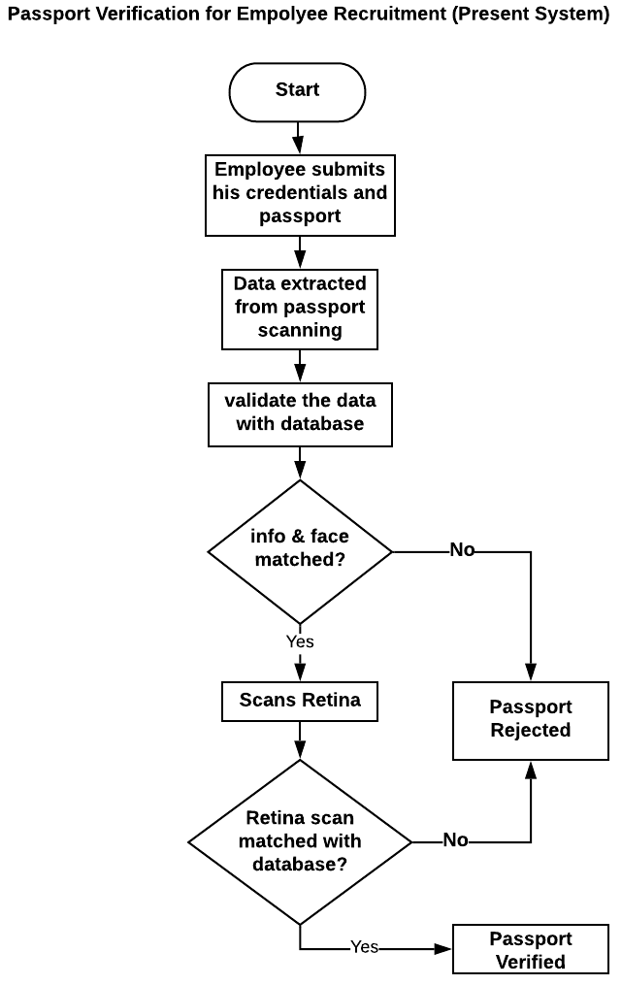

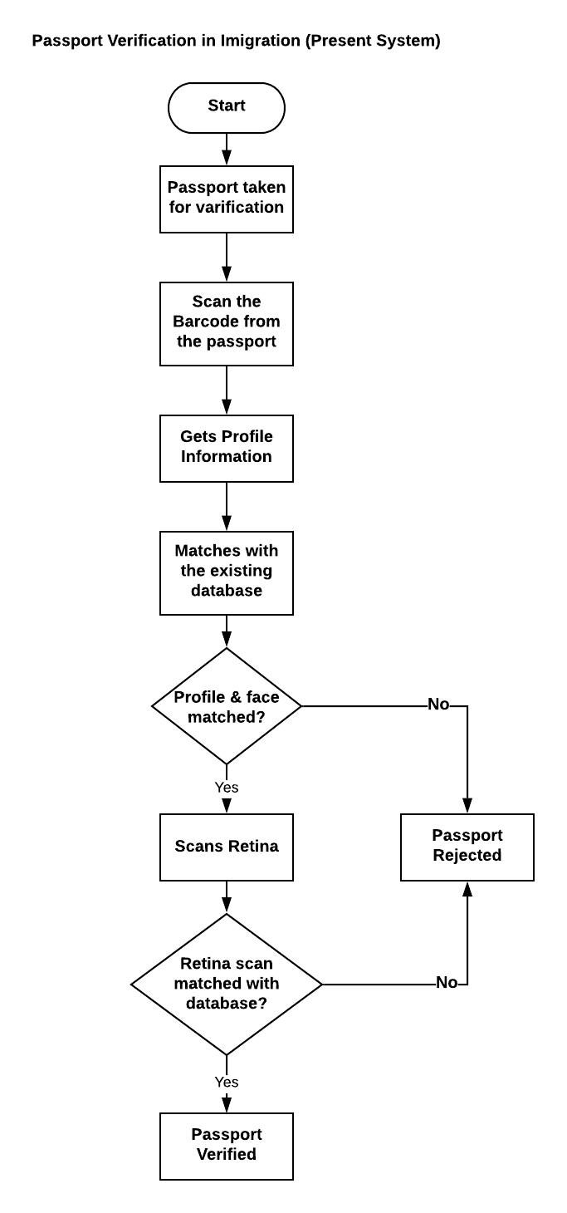

# 3. Proposed Candidate Systems

**POTENTIAL CANDIDATE SYSTEMS**

Initially we are proposing 2 candidate systems-

1. Block Chain Based Passport Verification System

2) Fog and Cloud Based Passport Verification System.

|  |  |  |  |  |
| --- | --- | --- | --- | --- |
| **Candidate System** | **Hardware Requirements** | **Software Requirements** | **Process** | **Features** |
| Block Chain Based  PV | (1)Personal Computer  (2)QR code generator | 1. QR code reading app 2. Hash Generator 3. Block Chain Network 4. Secure Database 5. Android app | (1)There will be a unique QR code and places the QR code inside of the passport  (2)A unique hash value will be generated for the passport and places this on the block chain  (3)We will populate a database with the unique hash value, block chain transaction record and URL of the PDF (to preview the passport original). | (1) Decentralized  (2)Data Transparent  (3)Open source  (4)Can not be updated without the permission of all nodes  (5)Immutable |
| **Candidate System** | **Hardware Requirements** | **Software Requirements** | **Process** | **Features** |
| Fog  and  Cloud Based  PV | 1. Personal Computer 2. Storage | 1. Cloud Server. 2. Network Server 3. RFID card reader | (1)It is a decentralized cloud computing infrastructure which facilitates computing, networking and storage of data on cloud. Being an extension of cloud computing, which allows us to compute, store and network services between the fogs or the nodes. Here, most of the data-processing takes place on a smart device. | (1)Decentralized cloud computing infrastructure.  (2)Compute, store and network services between the fogs or the nodes.  (3) Most of the data-processing takes place on a smart device. |

**CHARACTERISTICS OF THE CANDIDATE SYSTEMS**

|  |  |  |
| --- | --- | --- |
| **Components** | **Block Chain PV** | **Cloud based PV** |
| Android app | Required | Not Required |
| Source language | Python | Command |
| Hash Value | Required | Not Required |
| RFID card reader | Not required | Required |
| Block chain required | Yes | No |
| User Friendly | Yes | Yes |
| Cost of System Operation | Cheap | Moderate |
| Security | Very hard to hack | Less hard to hack |
| Storage type | Decentralized | Centralized |
| Reliability | Much reliable | Less reliable |
| Performance | Better | Average |
| Complexity | Low | High |

### **Performance and Cost-Effectiveness of the Candidate Systems**

**Table- Qualitative Matrix for the Proposed Candidate Systems**

|  |  |  |
| --- | --- | --- |
| **Evaluation criteria** | **Block Chain based PV** | **Cloud Based PV** |
| **Performance** | | |
| Performance Capacity | Excellent | Best |
| Manual Involvement | Very Good | Very Good |
| Accuracy | Good | Good |
| System Operation | Excellent | Good |
| Time Taken | Good | Good |
| Evolve Ability | Excellent | Better |
| Feedback | Good | Good |
| User Friendly | Yes | Yes |
| **Costs** | | |
| Cost of System Development | Less Expensive | Expensive |
| Cost of User Testing | Less Expensive | Expensive |
| Cost of system operation | Optimal | Minimal |
| Profit | High | Low |

**Table- Quantitative Requirements for the Proposed Systems**

|  |  |  |
| --- | --- | --- |
| **Evaluation criteria** | **Block Chain based PV** | **Cloud Based PV** |
| **Performance** | | |
| Performance Capacity | 90% | 80% |
| Manual Involvement | 80% | 80% |
| Accuracy | 90% | 85% |
| Time Taken | 75% | 70% |
| System Operation | 85% | 80% |
| Evolve Ability | 90% | 80% |
| Feedback | 80% | 80% |
| User Friendly | 80% | 80% |
| **Costs** | | |
| Cost of System Development | 50% | 60% |
| Cost of User Testing | 40% | 50% |
| Cost of system operation | 60% | 70% |
| Profit | 70% | 50% |

**Table- Weighted Matrix for the Proposed Systems**

|  |  |  |  |  |  |
| --- | --- | --- | --- | --- | --- |
| **Evaluation criteria** | **Weighting factor** | **Block Chain based PV rating** | **Block Chain based PV rating** | **Cloud Based**  **PV Rating** | **Cloud Based**  **PV** |
| **Performance** | | | | | |
| Performance capacity | 5 | 5 | 25 | 4 | 20 |
| Manual involvement | 3 | 3 | 9 | 3 | 9 |
| Accuracy | 4 | 4 | 16 | 3 | 12 |
| Time taken | 3 | 3 | 12 | 3 | 12 |
| System Operation | 5 | 5 | 20 | 4 | 15 |
| User friendly | 4 | 5 | 20 | 4 | 15 |
| Evolve Ability | 3 | 4 | 12 | 4 | 10 |
| Feedback | 3 | 3 | 14 | 3 | 12 |
| **Costs** | | | | | |
| Profit | 4 | 4 | 15 | 3 | 12 |
| Cost of system development | 5 | 3 | 15 | 2 | 10 |
| Cost of user training | 3 | 2 | 12 | 3 | 9 |
| Cost of system operation | 3 | 4 | 9 | 2 | 6 |
|  |  |  | 154 |  | 122 |

### **3.4 Selection of the Best Candidate Systems**

Among the two candidate systems we have selected the passport verification using block chain technology. And also block chain is more efficient then cloud based.

The reasons are specified below:

(1) It gives better performance compare to the 2nd system.

(2) It eliminates the dependability in other system at a great margin.

(3) It is more accurate than the 2nd candidate system

(4) It gives much more independence to the developer.

(5) Have almost no hassle with hardware.

(6) Creates a more user-friendly environment.

(7) Gives easy communication with the local authorities.

(8) User feedback is more positive than the other.

(9) It has taken less time than the other system

(10) It reduces operational costs.

1. Conclusions

Passport verification in Block Chain Passports or Visas facilitate safe movements across nations. Be that as it may, in 2016, the loss of almost 20,000 international IDs were accounted for. Such episodes lead to a rising alarm in wrongdoings like data fraud. Also, manual identification checks are wasteful, and it can cause delays in airports and borders.

The system which is selected through the analysis stages is comparatively cheap and efficient. Here the security system depends on hashing technique and authorities’ actions which reduces the cost significantly compared to the other existing system.

This challenge will be more stretched with the expanding number of voyagers. To battle the challenge in visa verification, the government needs to locate a compelling arrangement that Block chain innovation can give. Block chain for visa verification can be a smart solution for many reasons. This blog runs down the benefits of block chain in the passport and visa verification. Block chain can be called the future of visa verification or passport verification. The implementation of block chain technology in visa verification could be the eventual fate of the visa, as it offers an immutable digital ledger for verifying the individual identity.